***Assignment no.2***

**GUI using Javaf:**

Person Data form creation.

**Source Code:**

package com.example.assignment2;  
  
import javafx.application.Application;  
import javafx.geometry.Insets;  
import javafx.geometry.Pos;  
import javafx.scene.Scene;  
import javafx.scene.control.*;  
import javafx.scene.layout.*;  
import javafx.stage.FileChooser;  
import javafx.stage.Stage;  
import java.io.File;  
import java.time.LocalDate;  
import java.util.ArrayList;  
  
public class FormApp extends Application {  
 // ArrayList to store Person objects  
 private ArrayList<Person> personList = new ArrayList<>();  
 private String uploadedFilePath = null; // To store the uploaded file path  
 @Override  
 public void start(Stage primaryStage) {  
 Label banner = new Label("Person Form");  
 banner.setStyle("-fx-background-color: #C8E6F7; -fx-font-size: 24px; -fx-font-weight: bold; -fx-text-fill: navy;");  
 banner.setMinHeight(50);  
 banner.setAlignment(Pos.*CENTER*);  
 banner.setMaxWidth(Double.*MAX_VALUE*);  
   
 Label nameLabel = new Label("Name:");  
 TextField nameField = new TextField();  
 Label fatherNameLabel = new Label("Father Name:");  
 TextField fatherNameField = new TextField();  
 Label cnicLabel = new Label("CNIC:");  
 TextField cnicField = new TextField();  
 Label datePickerLabel = new Label("Date (Picker):");  
 DatePicker datePicker = new DatePicker();  
   
 Label genderLabel = new Label("Gender:");  
 RadioButton maleRadio = new RadioButton("Male");  
 RadioButton femaleRadio = new RadioButton("Female");  
 ToggleGroup genderGroup = new ToggleGroup();  
 maleRadio.setToggleGroup(genderGroup);  
 femaleRadio.setToggleGroup(genderGroup);  
 HBox genderBox = new HBox(10, maleRadio, femaleRadio); // Place them in a horizontal box  
 genderBox.setAlignment(Pos.*CENTER_LEFT*);  
   
 Label cityLabel = new Label("City:");  
 ComboBox<String> cityComboBox = new ComboBox<>();  
 cityComboBox.getItems().addAll("Lahore", "Karachi", "Multan", "Islamabad", "Peshawar");  
  
 Label fileLabel = new Label("File:");  
 Button uploadFileButton = new Button("Upload File");  
 Button saveButton = new Button("Save");  
 //ACTION OF UPLOAD FILE BUTTON..........  
 uploadFileButton.setOnAction(e -> {  
 FileChooser fileChooser = new FileChooser();  
 fileChooser.setTitle("Select File");  
 fileChooser.getExtensionFilters().add(new FileChooser.ExtensionFilter("Supported Files", "*.png", "*.pdf", "*.exe"));  
 File selectedFile = fileChooser.showOpenDialog(primaryStage);  
 if (selectedFile != null) {  
 uploadedFilePath = selectedFile.getAbsolutePath(); // Save the file path  
 System.*out*.println("File selected: " + uploadedFilePath); // Optional: log file path  
 }  
 });  
  
 // ACTION OF SAVE BUTTON..........  
 saveButton.setOnAction(e -> {  
 String name = nameField.getText();  
 String fatherName = fatherNameField.getText();  
 String cnic = cnicField.getText();  
 LocalDate date = datePicker.getValue();  
 String gender = maleRadio.isSelected() ? "Male" : femaleRadio.isSelected() ? "Female" : null;  
 String city = cityComboBox.getValue();  
 if (name.isEmpty() || fatherName.isEmpty() || cnic.isEmpty() || date == null || gender == null || city == null || uploadedFilePath == null) {  
 showAlert("Error", "All fields are required. Please fill out the form completely.", Alert.AlertType.*ERROR*);  
 } else {  
 Person person = new Person(name, fatherName, cnic, date, gender, city, uploadedFilePath);  
 personList.add(person);  
 showAlert("Success", "Person details saved successfully!", Alert.AlertType.*INFORMATION*);  
   
 nameField.clear();  
 fatherNameField.clear();  
 cnicField.clear();  
 datePicker.setValue(null);  
 genderGroup.selectToggle(null);  
 cityComboBox.setValue(null);  
 uploadedFilePath = null;  
 }  
 });  
   
 GridPane formGrid = new GridPane();  
 formGrid.setHgap(10);  
 formGrid.setVgap(10);  
 formGrid.setPadding(new Insets(20, 20, 20, 20));  
   
 formGrid.add(nameLabel, 0, 0);  
 formGrid.add(nameField, 1, 0);  
 formGrid.add(fatherNameLabel, 0, 1);  
 formGrid.add(fatherNameField, 1, 1);  
 formGrid.add(cnicLabel, 0, 2);  
 formGrid.add(cnicField, 1, 2);  
 formGrid.add(datePickerLabel, 0, 3);  
 formGrid.add(datePicker, 1, 3);  
  
 formGrid.add(genderLabel, 0, 4);  
 formGrid.add(genderBox, 1, 4);   
 formGrid.add(cityLabel, 0, 5);  
 formGrid.add(cityComboBox, 1, 5);  
 formGrid.add(fileLabel, 0, 6);  
 formGrid.add(uploadFileButton, 1, 6);  
 formGrid.add(saveButton, 1, 7);  
   
 GridPane.*setMargin*(saveButton, new Insets(10, 0, 0, 0));  
 saveButton.setMaxWidth(Double.*MAX_VALUE*);  
   
 VBox mainLayout = new VBox(10);  
 mainLayout.getChildren().addAll(banner, formGrid);  
 mainLayout.setAlignment(Pos.*TOP_CENTER*);  
   
 Scene scene = new Scene(mainLayout, 400, 500);  
   
 primaryStage.setTitle("Person Form with Banner");  
 primaryStage.setScene(scene);  
 primaryStage.show();  
 }  
 private void showAlert(String title, String message, Alert.AlertType alertType) {  
 Alert alert = new Alert(alertType);  
 alert.setTitle(title);  
 alert.setContentText(message);  
 alert.showAndWait();  
 }  
 public static void main(String[] args) {  
 *launch*(args);  
 }  
}  
  
// Person class  
class Person {  
 private String name;  
 private String fatherName;  
 private String cnic;  
 private LocalDate date;  
 private String gender;  
 private String city;  
 private String filePath;  
  
 public Person(String name, String fatherName, String cnic, LocalDate date, String gender, String city, String filePath) {  
 this.name = name;  
 this.fatherName = fatherName;  
 this.cnic = cnic;  
 this.date = date;  
 this.gender = gender;  
 this.city = city;  
 this.filePath = filePath;  
 }  
 @Override  
 public String toString() {  
 return "Person{" +  
 "name='" + name + '\'' +  
 ", fatherName='" + fatherName + '\'' +  
 ", cnic='" + cnic + '\'' +  
 ", date=" + date +  
 ", gender='" + gender + '\'' +  
 ", city='" + city + '\'' +  
 ", filePath='" + filePath + '\'' +  
 '}';  
 }  
}

**OUTPUT:**

**Empty Form:**

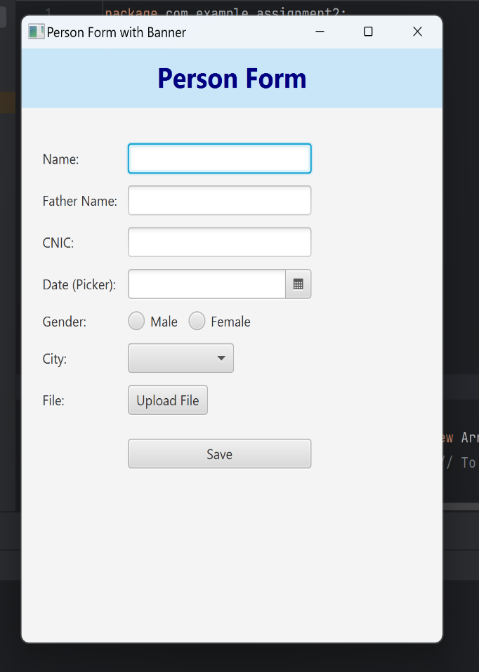

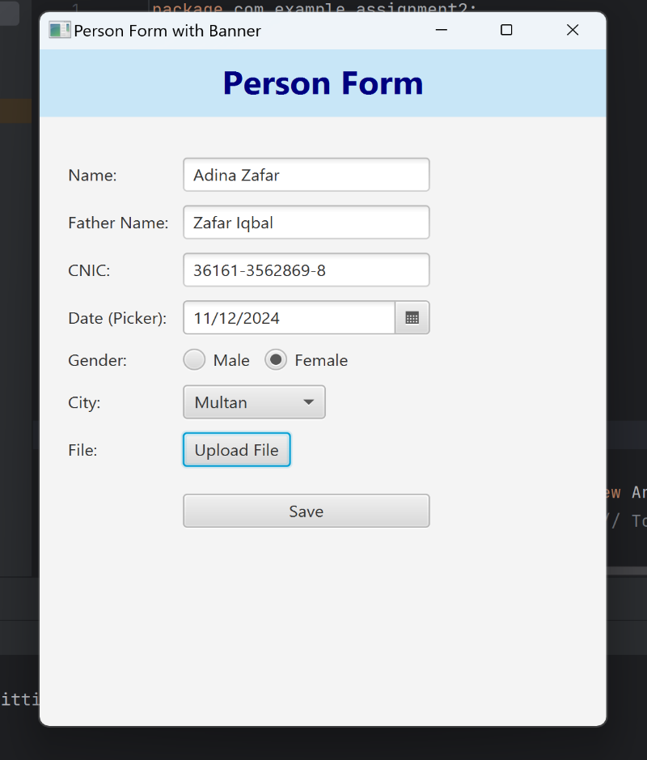**Form with Data:**

**File Uploading:**

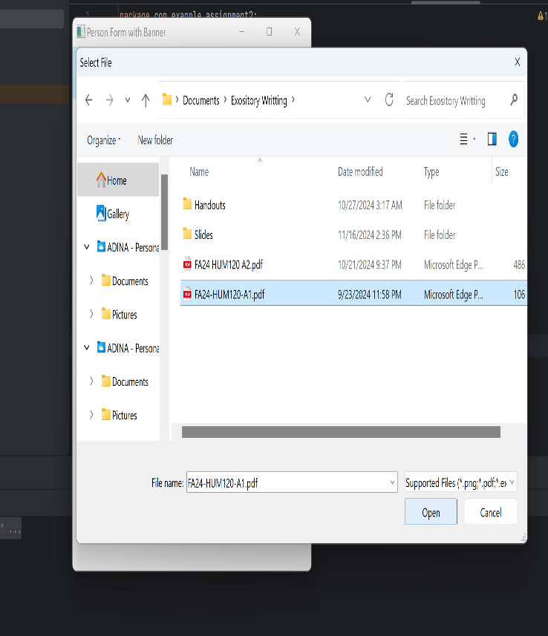

**Data Saved Successfully:**

